Crystal Application Tutorial: Comparing with pulse shear crystallisation data

# Load the molecular weight distribution

* The RepTate directory, find the folder RepTate/RepTate/data/Crystal/Acierno2003/
* Load the Molecular Weight Distribution application Click on the  icon on the top toolbar)
* From the folder ‘GPC’ drag and drop the file ‘Acierno116_GEX.gpc’ on to the Reptate window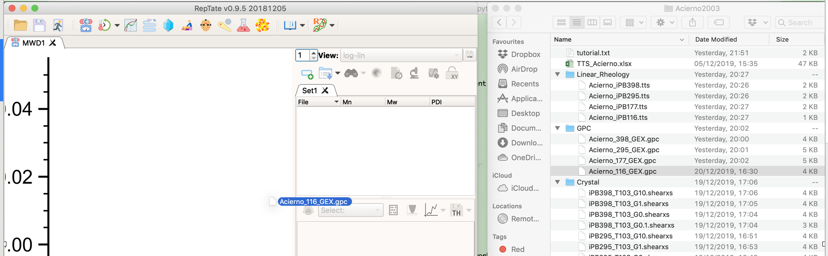
* Load the descritized MWD theory
* Choose 10 bins for the theory

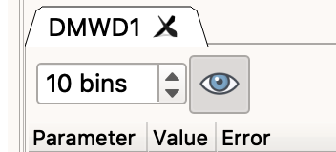

* Double click on ‘DMWD1’ and rename this iPB116

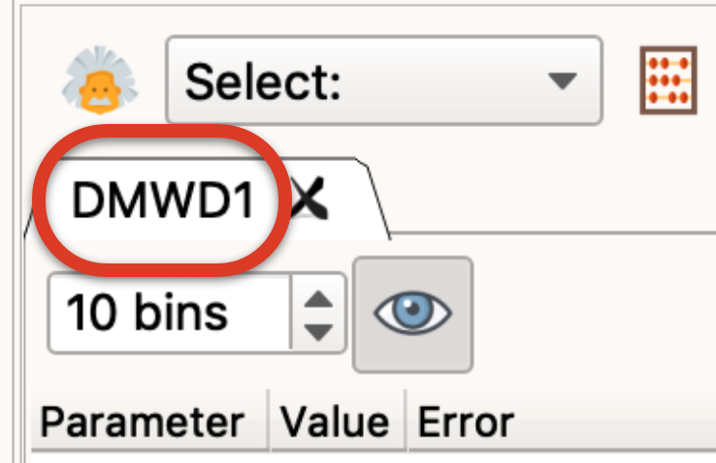

# Check MWD and tube model parameters against linear rheology

* Load the Crystal application (Click on the  icon on the top toolbar)
* From the folder ‘Linear_Rheology’drag and drop the file ‘Acierno116.tts’ on to the Reptate window 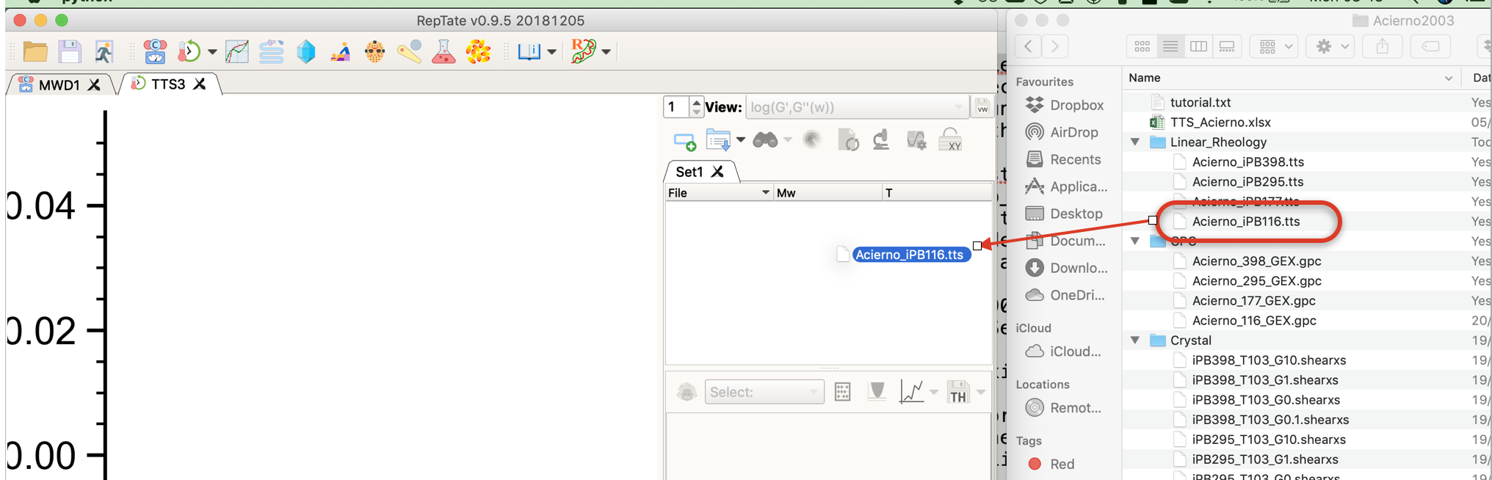
* Load RDP LVE theory (the linear viscoelastic version of the Rolie-Double Poly model)

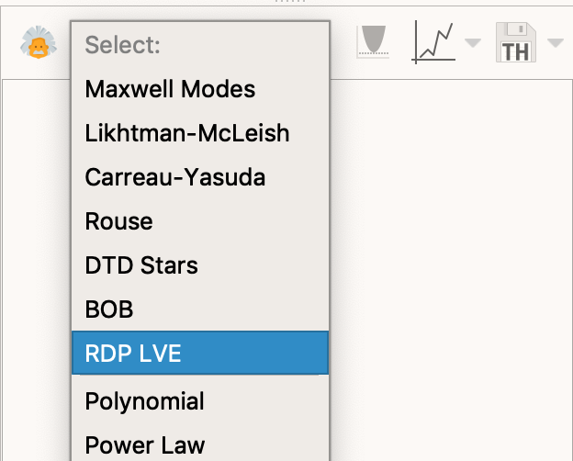

* Click 'Get modes (MWD app)'

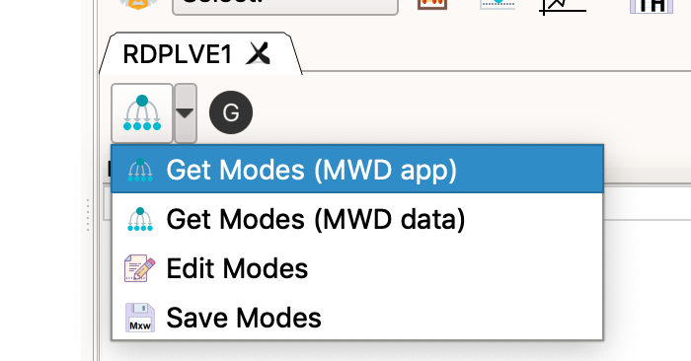

* Set Me=9.5e3; taue=3.90E-06; choose MWD1.Set1.iPB116 from the list of molecular weight distributions; and click OK to exit



* Click the Modulus Correction button and set GN0= 2.60E+05 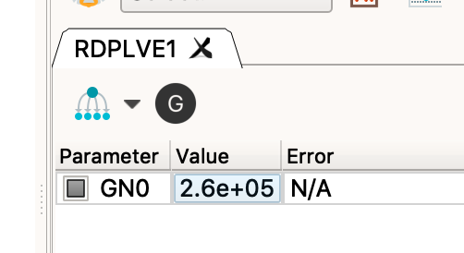
* You should see something like

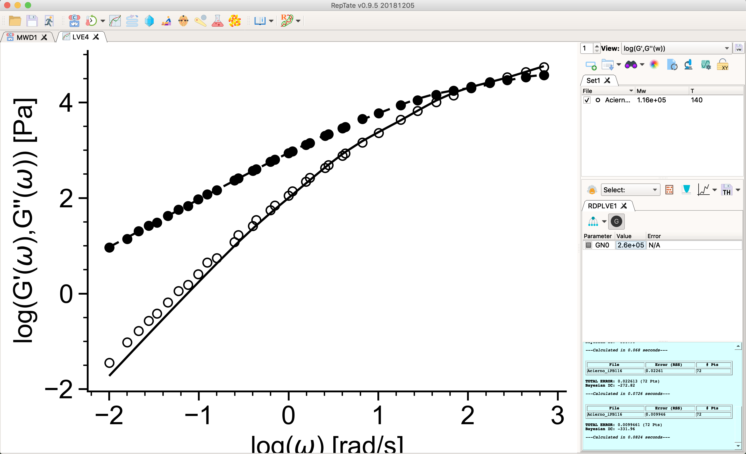

This confirms that the tube model parameters and molecular weight distribution capture the linear rheology.

# Load data and set the view

* Load the Crystal application (Click on the crystal application  on the top toolbar)
* From the folder ‘Crystal’ drag and drop the 4 files that begin ‘Acierno116’ and end ‘.shearxs’ on to the Reptate window 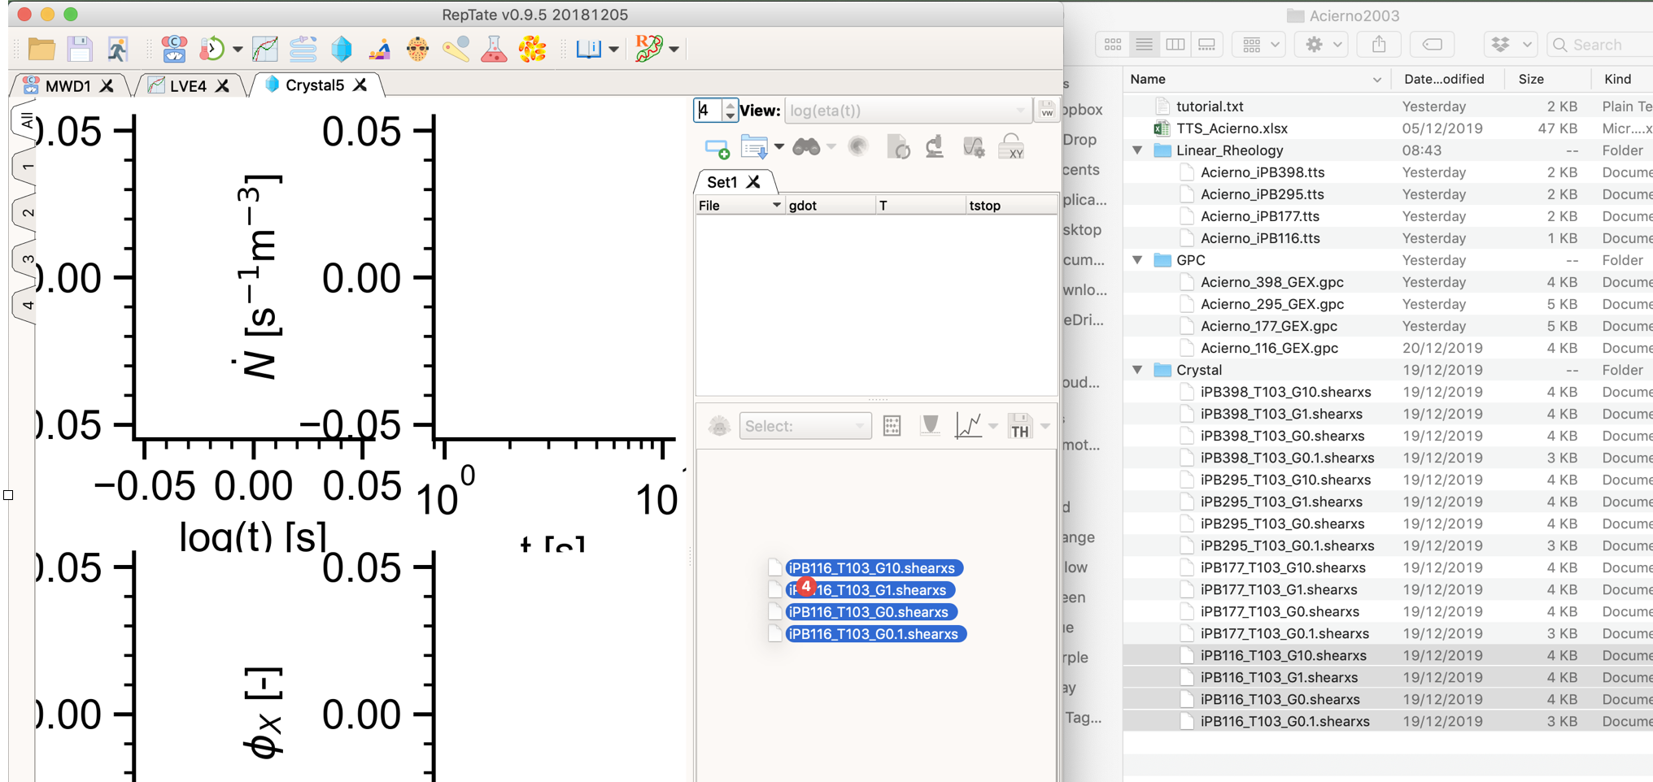
* Select view 1 (on the upper left of the window)

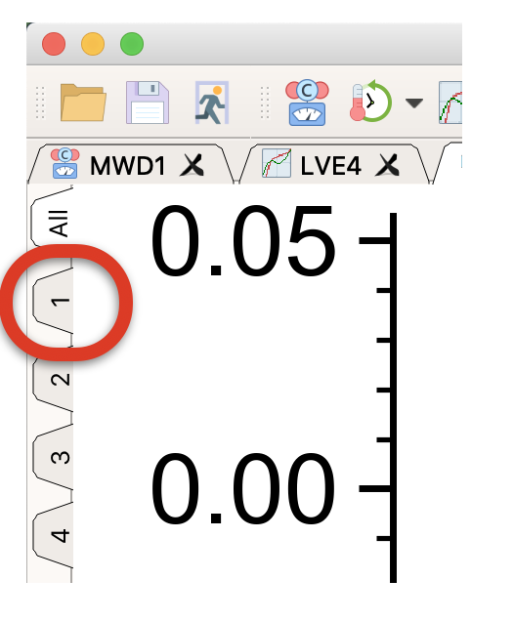

* From the ‘views’ list (upper right of window), select ‘sigma(log(t))'
* 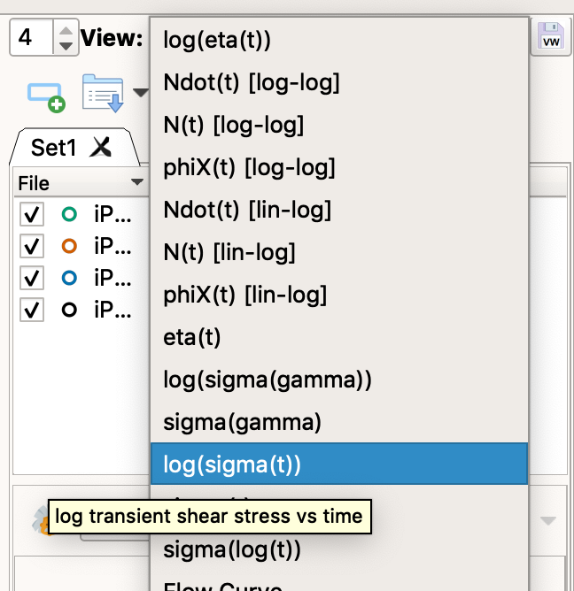
* Go to view 4 (upper left of window) and from the views list select ‘phiX [lin-log]’
* Choose view ‘All’ (upper left of window)
* Load GO-polyStrand model (choose the model from the drop down list and then click the theory icon )

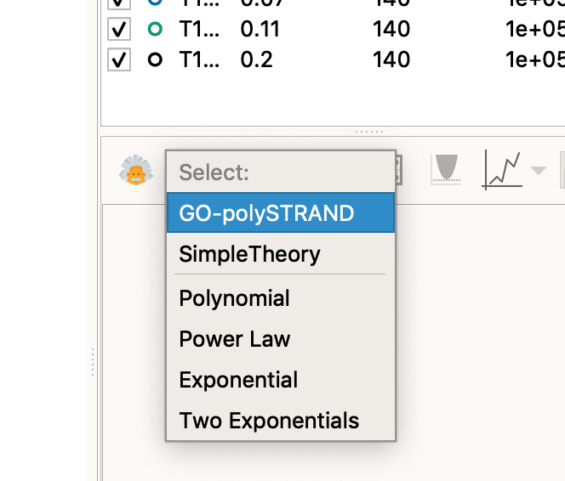

* Click 'Get modes MWD app'

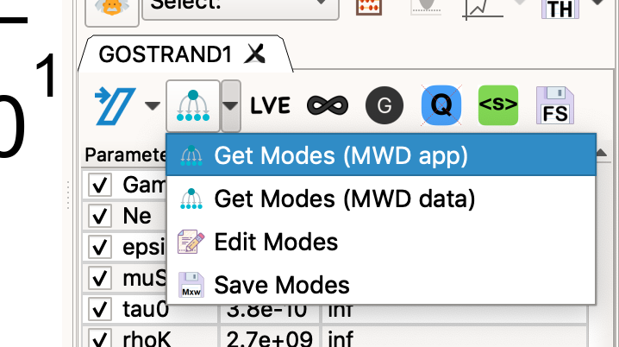

* In the pop-up window set Me=9.5e3; taue=2.340E-05; choose MWD1.Set1.iPB116 from the list of molecular weight distributions; and click OK to exit

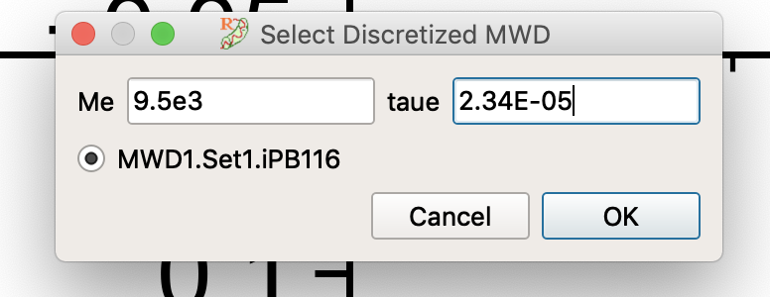

This is the taue from the linear rheology comparison above, but shifted to the temperature of the crystallisation experiments (140oC -> 103oC).

* Click the ‘Modulus Correction’  and ‘Ignore Quiescent’  buttons.
* Set the model parameters

Gamma 2

Ne 9

epsilonB -0.002

muS 1.04

tau0 3.12e-07

rhoK 5.3e+08

G_C 0.063

N_0 1.3e-12

GN0 260000

You can enter these by hand or copy these parameters and then choose ‘Paste Parameters’

* Click to run the model [This should take about 30 seconds]. You should now see

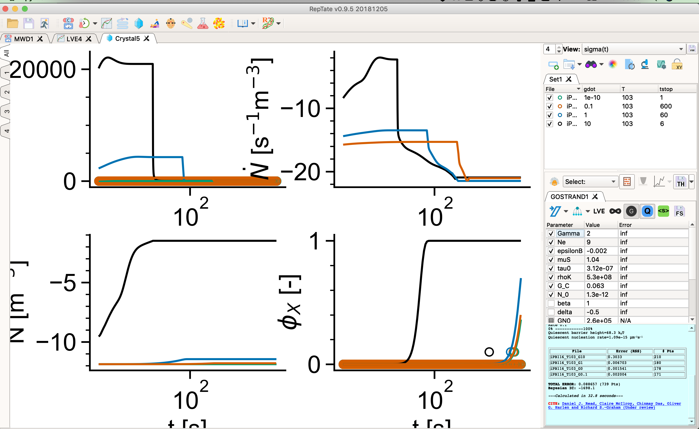

* Close the mode window by clicking 'Ok'

# Focus on the region of the measurements

* Choose view 4 (upper left part of the window)
* Click ‘show/hide’ toolbar’  (top right corner underneath the views selector)
* Click the ‘Edit axis’ button  (lower left region) to bring up the axis properties
* Change the X-Axis: Left value to ‘1e3’
* Click ‘Apply’ or ‘Ok’
* Click ‘Lock XY axis’ icon (top right corner)
* You should see

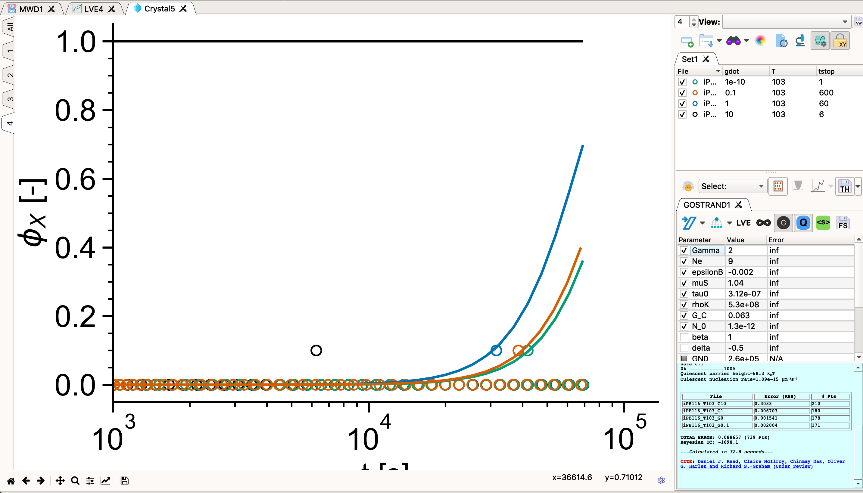

# Things to try

* Change Gamma to adjust the sensitivity to shear
* Make *small* changes to epsilonB to adjust the quiescent barrier (equivalent to changing temperature)
* Change the molecular weight distribution by clicking ‘Get modes (MWD data)’ and changing the Molar Mass values (M) by hand. You can also change phi but this needs to add up to 1.
* Increase the resolution of the molecular weight distribution by using more modes to discretize the molecular weight distribution.

# Model the other molecular weights in the series

* Repeat steps 1-4 for the other 3 molecular weights in the series (iPB177, iPB295 and iPB398).
* You’ll find GPC, linear rheology and crystallisation data in the same folders.
* All model parameters are the same as above, except for taue and N_0. (I also used slightly different numbers of modes for the discrete molecular weight distributions but this should not affect the results).
* Suggested parameters are:

iPB177

RDP modes:11

Tau_e (140oC): 3.5e-06

Tau_e (103oc): 1.53E-5

N_0: 8.3e-12

iPB295

RDP modes:14

Tau_e (140oC): 3.30E-06

Tau_e (103oc): 1.49E-5

N_0: 12e-12

iPB398

RDP modes:12

Tau_e (140oC): 2.30E-06

Tau_e (103oc): 7.90E-6

N_0: 37e-12

* You should find that the model overpredicts the crystallisation kinetics for large shear rates, particularly at higher molecular weights.